CPU
Processor Organization:
1. Register based CPU organization
2. Accumulator based CPU organization
3. Stack based CPU organization

Accumulator based CPU organization:
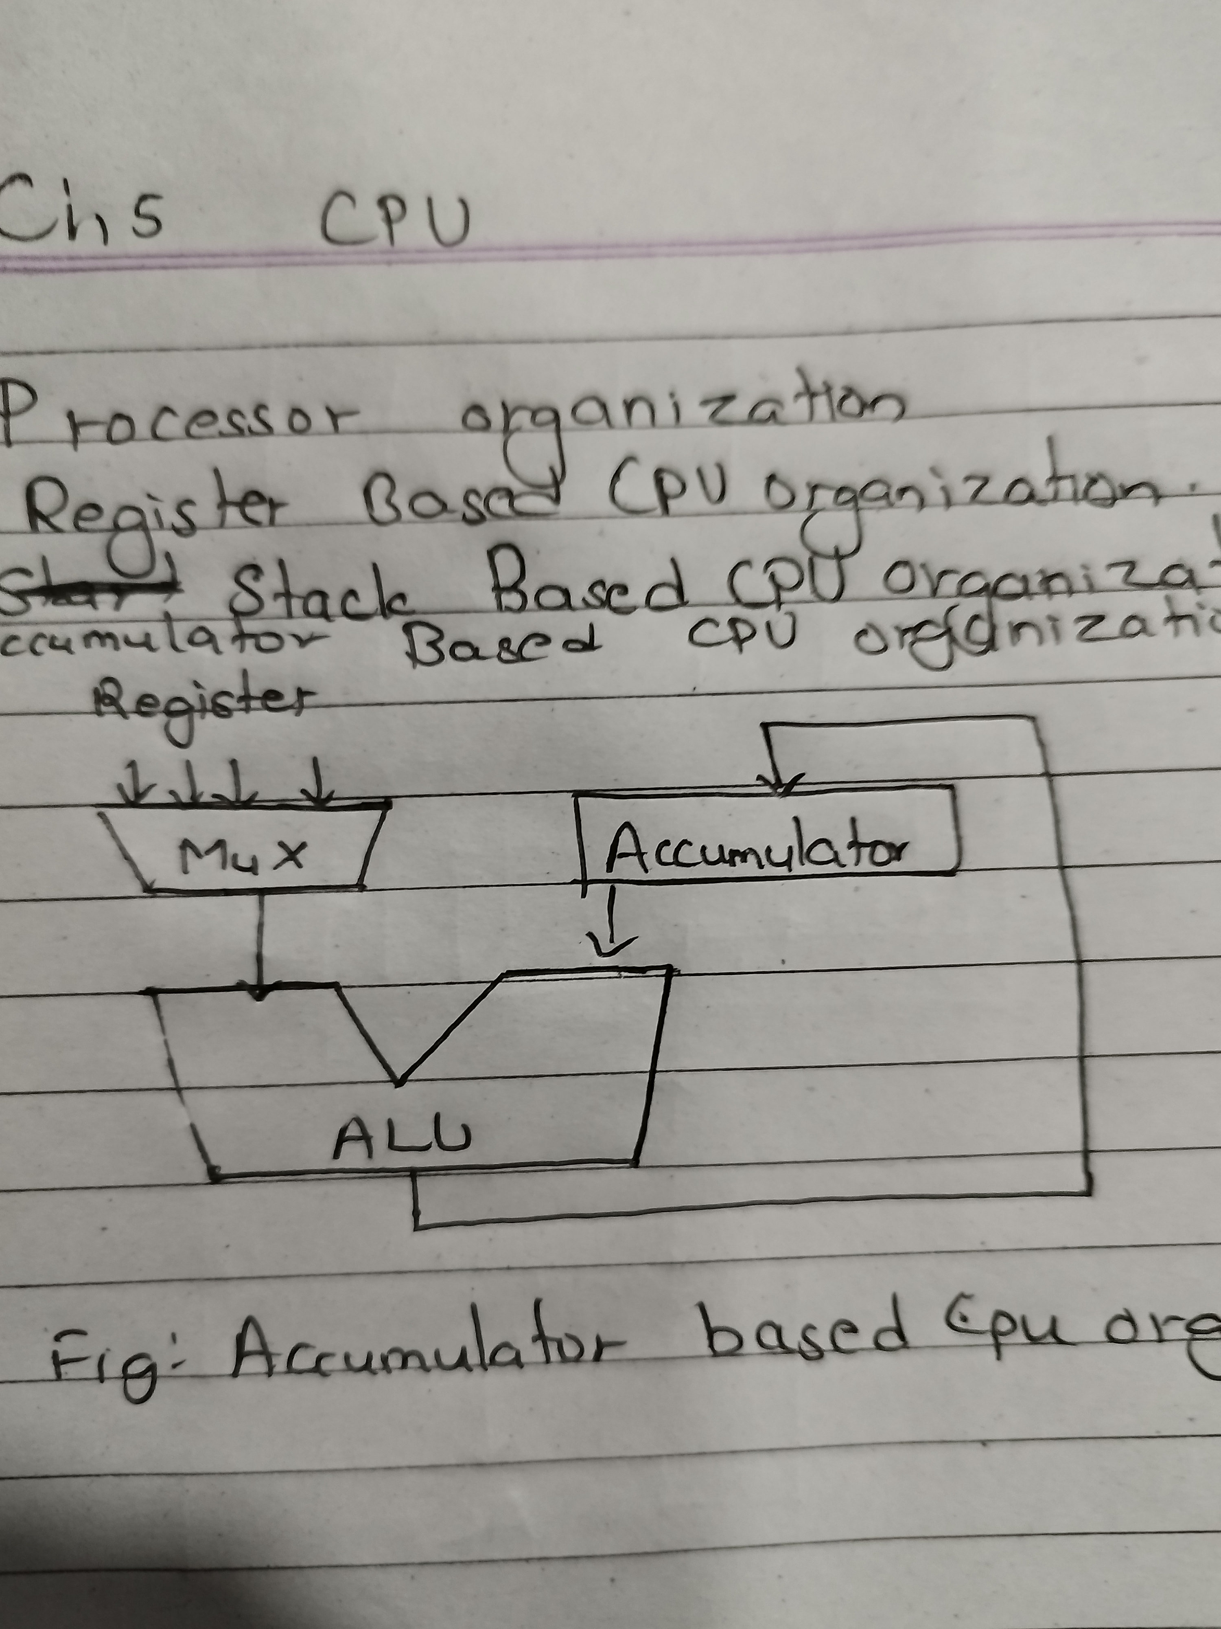
Stack Based CPU organization:
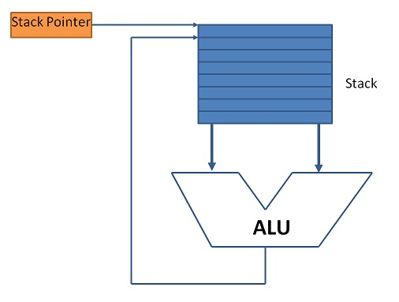

Instruction Format:
1. Three address instruction format
→ MUL R1 ,A ,B // R1 ← M[A] * M[B]

2. Two address instruction format
→ MOV R1 ,A // R1← M[A]
→ MUL R1 ,B // R1 ← R1 * M[B]

3. One address instruction format
→ MUL R1 // A_{C} ← A_{C} * R1

4. Zero address instruction format [stack based CPU organization]
→ The expression (A*B)+(C*D) in zero address format will be as follows:
 |  |  |  | D
 | B |  | C | C | C*D
A | A | A*B | A*B | A*B | A*B | (A*B)+(C*D)
*each column is a step and step progresses from left to right.

Program:
PUSH A
PUSH B
MUL
PUSH C
PUSH D
MUL
ADD
POP X
* to write this program convert expression to postfix notation.

Addressing Modes:
The way of specifing operand in an instruction.
Instruction = opcode + operand
- Immediate → MVI A , 05H
- Implied → CMA
- Direct → LDA 2000H
- Indirect → ILDA 1000H (Address of address of operand)
- Register → ADD B
- Register Indirect → ADD M (M contains address of operand)
- Displacement
  - Relative → EA = address + PC (EA=effective address)
  - Index → EA = address + IR (IR=index register)
  - Base → EA = address + CS (CS=code segment)
  - Base + Index → EA = address + CS + DI (DS=destination index)
- Auto Increment / Decrement

RISC vs CISC:
Reduced Instruction Set Computer | Complex Instruction Set Computer
Small number of instructions | Large number of instructions
Simple hardware | Complex hardware
Complex software/complier | Simple software/compiler
Large number of registers | Less number of registers
Less addressing mode | Large number of addressing mode
Hardwired control unit | Microprogrammed control unit
Load and store instructions are used for memory access | Multiple instructions available for momery access
Instruction completes in one cycle | Instructions completes in multiple cycles
Efficient pipeline implimentation | Pipeline if implimented not efficient
Fixed length instruction | Variable length instruction
Eg ARM , RISC-V , etc | Eg VAX , x86_64 , etc

Register overlapped window:
Available in RISC having large number of registers.
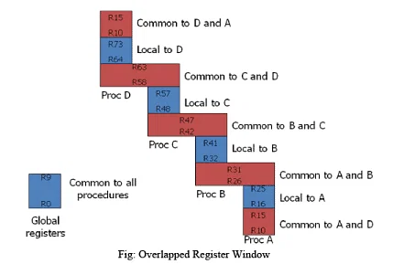

Number of gobal registers = G
Number of local registers in each window = L
Number of common registers common to windows = C
Number of windows = W
Window size = L + 2C + G
Register file = (L+C)W + G

